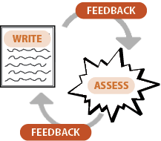
INSTRUCTIONS  - Print the template: Print page 2.  - Position 6 sticky notes: Carefully adhere a 3x3 sticky note within each box of the printed page 2. Set aside.  - Input information: Scroll to page 3 and determine the universal information you want printed onto each sticky note (e.g., Compliment, Comment).  - Load the printer. Feed page 2 with its sticky notes into the printer, ensuring proper alignment.  - Print Sticky-Note Messages. Within the print settings, print only page 3, selecting the “manual feed” option.  HELPFUL TIPS  - Ensure that the adhesive side of the sticky notes are facing the printer's feed mechanism to prevent potential paper jams.  - To maximize efficiency, print a sufficient number of page 2 templates for your entire class. For example, if you have 24 students, print 4 copies of page 2. Load up 6 sticky notes on each of the 4 printouts to have 24 sticky notes ready to print. Set the document to print 4 copies of page 3 only. Manually feed each sticky-note template into the printer one at a time. | 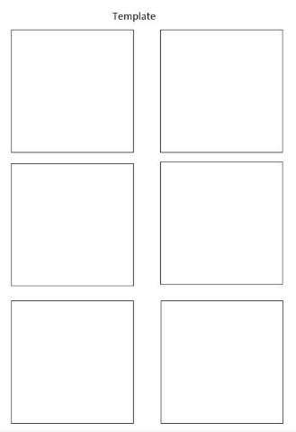  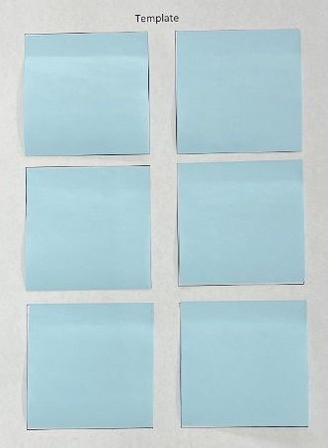  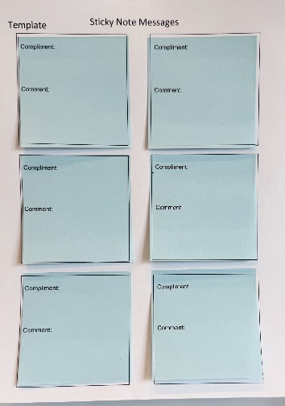

Smekens Education Solutions, Inc.
Template

Sticky-Note Messages

Compliment:

Comment:

Compliment:

Comment:

Compliment:

Comment:

Compliment:

Comment:

Compliment:

Comment:

Compliment:

Comment:

